Tachometer View Control Function – CGEA1.3

Functional Description

The Tachometer View Control Function allows the driver to change a single gauge view to a dual gauge view that includes the Tachometer gauge. This setting will not affect standard dual gauge views.

The customer uses the message center switches and display to enable and/or change the Tachometer View settings in the vehicle. Due to market preference, the Tachometer_View_MC default value at Battery Connect will be based on Speedo_Cal_Cfg.

Interfaces

Interface Context Diagram (I/O Block Diagram)
Figure 1 Tachometer View Control Function Context Diagram
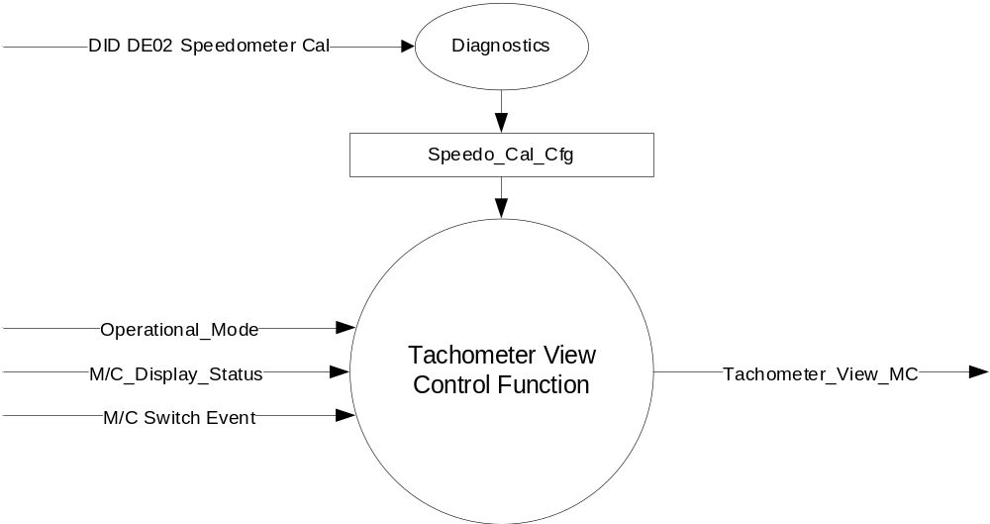

Inputs

- INTERNAL:
- Speedo_Cal_Cfg
- Operational_Mode
- M/C Switch Event
- M/C_Display_Status

Outputs
- Tachometer_View_MC

Function/Performance

Operational Modes

Mode | Differentiating Vehicle Conditions
Sleep Mode | Tachometer View Control Function Text Messages Disabled
Limiting Mode | Tachometer View Control Function Text Messages Disabled
Normal Mode | Tachometer View Control Function Text Messages Enabled / Disabled
Crank Mode | Tachometer View Control Function Text Message Enabled / Disabled

Voltage Levels

Refer to the Cluster Features table located in the Operational Modes and Voltage Range Strategies Section in this SPSS.

Human-Machine Interface

Visual

Indicator Graphics / Display Format
For program specific display, refer to “<Program> Cluster Menu Structure.xls” and Program VAPS Model.

Level 2 | Level 3 | Comment
Display Setup > | # Add Tachometer to View | Changes single to dual gauge view. Adds Tachometer to the view

Indicator Color Coordinates

Reference section COLOR & ILLUMINATION REQUIREMENTS (GRAPHICS)

Indicator Characteristics

Refer to Message Center X Display_Y Button Interface Section, where X and Y are appropriate values in this document.

Audio

None

Switch Control Logic

Consumer access to the Tachometer View Control Configuration shall be as specified in the message center basic functionality display as specified in Message Center X Display_Y Button Interface Section, where X and Y are appropriate values in this document.

System Accuracy

Within a 100msec of receiving a message that results in a change of state the cluster will update the display to the proper status.

Operation: Performance and Functional

Subsystem Algorithm Flowchart / State Diagram

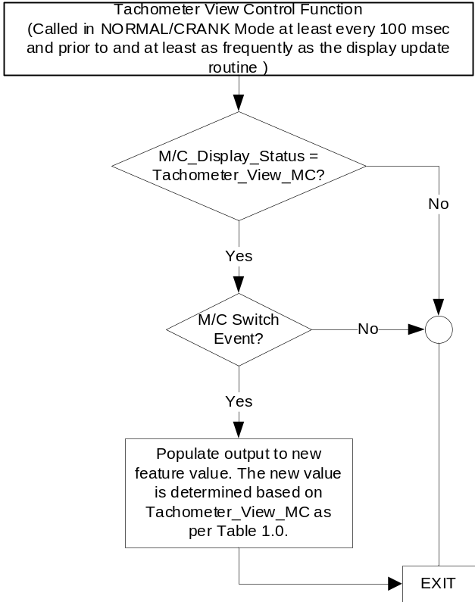

NOTE: In the Tachometer View Control Function Flowchart, the definition of "M/C Switch Event" is defined in Message Center X Display_Y Button Interface Section, where X and Y are appropriate values in this document.

Operation Description (supports algorithm flowchart /state diagram)

- Tachometer_View_MC based on User Input
Tachometer_View_MC | Display Menu | 5-Button Switch Selection Event | Tachometer_View_MC
Off (0x0) | ◻ Add Tachometer to View | OK Press | On (0x1)
On (0x1) | ☑ Add Tachometer to View | OK Press | Off (0x0)

Function Safety Classification (EMC)

Class B

Memory Storage

Parameter Name | Description | Value at  Battery Connect | Value at  Module Wake-up
Tachometer_View_MC | Output displayed in the M/C | See Table 1.1 | Do Not Init
M/C_Display_Status | State Indicator to identify which text is currently being displayed on Message Center display. See * | See * below | See * below
M/C Switch Event | Event that is indicated as per the switch interface for the Message Center. See * | See * below | See * below
Operational_Mode | 4 state indicator for cluster operational mode | Limited | Limited, Normal or Crank
Speedo_Cal_Cfg | State Indicator for speedometer calibration controlled via CAN at EOL at VO plant. Defaulted to Non-EC at supplier manufacturing. | Use Stored Value | Use Stored Value

* Refer to Message Center X Display_Y Button Interface Section, where X and Y are appropriate values in this document.

- Tachometer_View_MC Value at Battery Connect based on Speedo_Cal_Cfg
Speedo_Cal_Cfg | Tachometer_View_MC Value at Battery Connect
0x0 (Non-ECE) | Off (0x0)
0x1 (ECE) | On (0x1)

Reconfigurable Telltale

Not Applicable

Prove Out

Not applicable

Message Center Msg

Message IDs to be assigned.

Error Handling

Missing Message Strategy

Not Applicable

Diagnostics

Self Test

None

Engineering Test Mode

Reference section “Dealer / Engineering Test Mode (ETM)”

Part II Performance

Supported Diagnostic Trouble Codes (DTCs)
DTC | Description

DID DExx:
Block  Num | Block Description | Size (bits) | Type | Byte(s) | Bits | State: Description | "0" | "1" | Default | Comments/Information
PACKETED BLOCKS
$02 | Option Content (B&A) | * | 1 | * | * | Speedometer Cal | Non-ECE | ECE | Non-EC | Non-ECE = U.S., Canada, Mexico  ECE = GCC, China, most export countries
 | *Byte and bit location to be identified in Part II Specification for this cluster

Reference Specification

None.

Revision History
SPSS Module Revision History
Revision Level | Name | Change Description | Date
1.0 | J. Gregoire | Initial Release | 5/26/2016
1.1 | J. Gregoire | Changes highlighted in Yellow.  DI CC 10/11/2018  Change Request ID: 100154  Change Requester: Angela Allgaier  Program lead: Bx726, Cx482  Change Request: Add speedometer bias cfg bit to set default value of Tachometer = Enabled for FoE.  Page 1 Section 1.1 – Add note on market preference.  Page 1 Figure 1 – Add Speedo_Cal_Cfg.  Page 1 Section 1.2.2 – Add Speedo_Cal_Cfg.  Page 4 Section 1.3.5.4 – Add Speedo_Cal_Cfg.  Page 4 Table 1.1 – New table for Tachometer_View_MC Value at Battery Connect based on Speedo_Cal_Cfg  Page 5 Section 1.5.3 – Add Speedo_Cal_Cfg. | 11/07/2018

